Proposal for BALL OF YARN Emoji
Submitted by: Amanda Hickman, Amberley Romo
Date: July 1, 2017

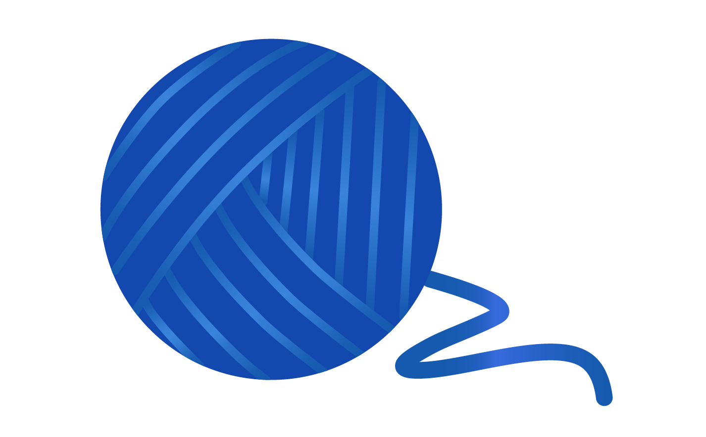

Abstract
We are requesting the addition of a BALL OF YARN emoji. Depending on vendors’ renditions. It could interpreted as BALL OF STRING The addition of a yarn- and string-related emoji would fill a gaping hole in the extremely limited craft and textile sets.

Introduction
Though the emoji character set includes glyphs for a number of machinery and construction tools (eg. 🔨 🔧 and 🔩) there are no glyphs for the making, mending, or maintenance of textiles. Notably, the available tool glyphs are all strongly associated with trades traditionally dominated by men, while trades and crafts such as knitting and sewing have historically been associated with women's work and interests.

History

Due to the fragility of materials used to create YARN, it is not surprising that there is little preserved evidence of them. In 2016, archaeologists studying ruins in England found artifacts shedding light on the late Bronze Age — 3,000 years ago, including, “balls of thread, hanks of yarn, and fine linen.” The oldest known example of a knitted object dates back to 11th century Egypt but the complexity of the design of those ancient Egyptian socks suggest that knitting was not new, even then.

Names
(Suggested short name and keywords, as in the Emoji List).

- YARN
- TWINE | STRING | ROPE | CORD | WOOL

Images

Artwork created by Cherin Sanih / cherinsanih.com

Selection Factors Inclusion

A. Compatibility
Currently, there are no yarn or fiber-art related emojis in use by major platforms. There is a released app (Craftmoji) which supplies craft stickers/imagery.

B. Expected Usage Level

Frequency
There is a very high expected frequency of use, worldwide. The practice of fiber arts in general (including, but not limited to, knitting and crochet) is global. Ravelry, the largest and most prominent online community of “knitters, crocheters, designers, spinners, weavers and dyers” has over 6.5 million registered users. Reddit hosts thriving fiber communities, with countless spinoffs:
- Knitting (56k+ subscribers)
- Crochet (50k+ subscribers)
- Sewing (58k+ subscribers)

The #yarnemoji hash tag has been in active use on Twitter and Instagram since at least 2015.

Variations on "yarn" and various fiber arts are hugely popular on Instagram. As of June 2017, Instagram users had used these tags tens of millions of times:
#yarn -- 3,022,054 posts
#knitting -- 7,069,283 posts
#knit -- 4,269,454 posts
#crochet -- 11,406,507 posts

Multiple Usages

A BALL OF YARN emoji can be used to represent any number of coiled fibers or filaments including twine, rope, or string. BALL OF YARN can be used to convey a wide spectrum of fiber arts including crochet, macrame, amigurumi, knitting, weaving, and spinning.

A long and elaborate narrative (real or fictitious, but often unbelievable) is also called a YARN, while the telling of such stories is "spinning yarns" — a YARN emoji can also be used to represent entertaining, complex, or dubious stories and storytellers. And YARN is famously popular as a toy for 🐈 cats.

In computing, Yarn is currently the name of a popular package manager. The BALL OF YARN or string could also be used to represent string theory, a foundational theoretical framework in physics.

C. Image Distinctiveness
A BALL OF YARN emoji would be fully distinct from any in the current emoji set.

D. Completeness
The BALL OF YARN emoji would go a very long way toward closing a giant hole in the current selection of available crafting-related emoji. The BALL OF YARN emoji is broadly applicable to the fiber arts community at large — both knitters, crocheters and others.

We are not aware of an existing YARN or BALL OF YARN emoji on any of the major platforms, though "Craftmoji" supplies craft stickers/imagery (though not as keyboard-accessible emoji) that include knitting and crocheting themes.

E. Frequently Requested
Twitter users regularly lament the absence of a YARN emoji. To wit:
  - https://twitter.com/kentcdodds/status/786220453685633026
  - https://twitter.com/FarahA30/status/787907196763766784
  - https://twitter.com/lucianekmd/status/787129130613559301
  - https://twitter.com/_novasaint_/status/785923988375474176
  - https://twitter.com/SerenaTV__/status/766335413959192576
  - https://twitter.com/amyhoy/status/788520865214390272

Related crafts like Knitting and Sewing are consistently among the top emoji requests. See: 2016 and 2017.

Selection Factors Exclusion

F. Overly Specific
YARN may be made from any number of animal (eg. alpaca, angora, wools, silk), plant (eg linen, cotton, bamboo, hemp) or synthetic fibers. A ball of yarn is a very generic form that any number of fibers can take.

G. Open Ended
YARN does not open up a new category of emoji. Rather it takes a large step in completing the existing set, especially in combination with the several other textile emoji proposals we have submitted.

H. Already Representable
➰ and ➿ are sometimes used to represent string or thread. In combination with the EWE, GOAT or RAM, they can indicate wool, but these are vague approximations.

I. Logos, brands, UI icons, signage, specific people, deities
A search of the WIPO Trademark Database for logos with "Image Class: US.09.01.01" (or "thread or wool, wound or unwound") turns up twelve hundred different logos that incorporate thread, yarn, or spools in some way. These common household objects that are too generic to be a trademark for any one brand.

The images we are submitting do not have any significance that would make them
unsuitable for encoding as a character. There are no copyright, religious, or issues that
reference anyone historic or living.

J. Transient
Humans have been knitting since at least the 11th century and were working with yarns and other fibers well before that. There is no sign that we're winding down.

K. Faulty Comparison

Sort location
(Proposed sort location for the emoji in Emoji Ordering)

- Object-textiles, to be added after tool and before medical

Other Information

Author Bios (optional)
Amberley Romo (amberleyjohanna@gmail.com) is a software developer and avid knitter. Amberley grew up (and currently lives in) Texas, and has been very involved in the fiber arts communities of both Washington, DC and Austin, TX. She is passionate about knitting as a meditative practice, and community activity.

Amanda Hickman (amanda@velociraptor.info) runs a fellowship program that helps creative technologists collaborate with journalists on storytelling and audience engagement projects. She has been sewing since she was six years old, and cherishes the independence afforded by mending, altering and making her own clothes. She is only just learning to knit.

Character Properties
The other character properties are suggested to be defined as follows.
General Category:
Canonical Combining Class:
Bidirectional Class:
Decomposition Type:
Decomposition Mapping:
Numeric Type:
Numeric Value:
Bidirectional Mirrored:
Name:
ISO Comment:
Simple Uppercase Mapping:
Simple Lowercase Mapping:
Simple Titlecase Mapping: se Mapping: Simple Titlecase Mapping:

https://www.sciencemag.org/news/2016/07/bronze-age-inferno-preserved-extraordinary-view-life-united-kingdom-3000-years-ago
https://en.wikipedia.org/wiki/History_of_knitting#cite_note-2
http://www.ravelry.com/
https://twitter.com/hashtag/yarnemoji
https://www.instagram.com/explore/tags/yarnemoji/
http://blog.emojipedia.org/top-emoji-requests-2016/
http://blog.emojipedia.org/top-emoji-requests-2017/
http://www.wipo.int/branddb/en/

